**Commodore Keyboard Tester Rev. 2**

**Module Description**

# Introduction

They keyboard tester aims at testing Commodore matrix keyboards with an ohm meter (multi meter) without disassembling the keyboard.

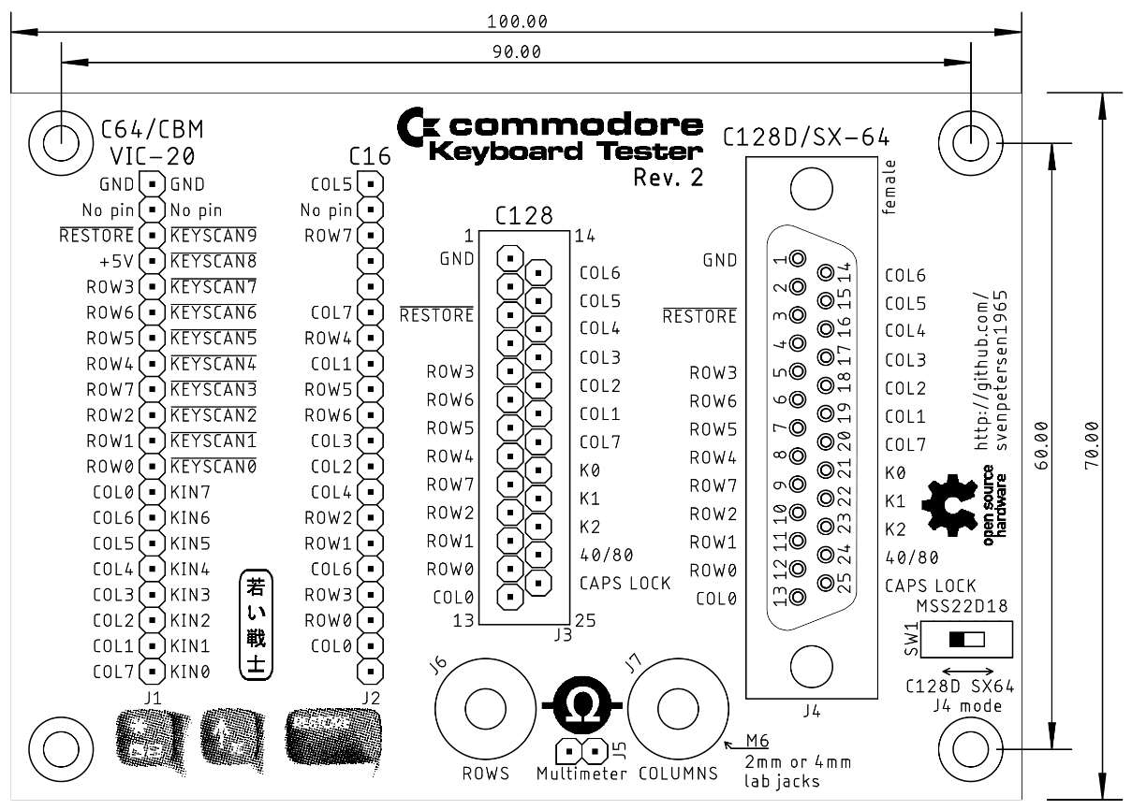

Figure 1: Commodore Keyboard Tester Rev. 1

Each button in a matrix keyboard is connected to one column and one row signal. If all rows are connected to on lead of the multi meter and all columns are connected to the other lead of the multimeter, a key press will connect both sides, no matter, which key it is. Assuming, that no 2nd key is pressed, the reading on the ohm meter is the impedance of the pressed key plus the traces and cables.

# Keyboard Matrices

## C64/VIC-20/PET

The VIC-20, C64, and PET (Graphic and Business Keyboard) have the same connector (a 20 pin header with the 2nd pin missing as a keying for the direction.

|  |  |  |  |  |  |
| --- | --- | --- | --- | --- | --- |
| Connection | C64/VIC20 | Pin | Pin | PET/CBM | Connection |
| COLS | GND | 1 | 12 | GND | (COLS) |
| - | No pin | 2 | 11 | No pin | - |
| ROWS | RESTORE | 3 | 10 |  | ROWS |
| (ROWS) | +5V | 4 | 9 |  | ROWS |
| ROWS | ROW3 | 5 | 8 |  | ROWS |
| ROWS | ROW6 | 6 | 7 |  | ROWS |
| ROWS | ROW5 | 7 | 6 |  | ROWS |
| ROWS | ROW4 | 8 | 5 |  | ROWS |
| ROWS | ROW7 | 9 | 4 |  | ROWS |
| ROWS | ROW2 | 10 | 3 |  | ROWS |
| ROWS | ROW1 | 11 | 2 |  | ROWS |
| ROWS | ROW0 | 12 | 1 |  | ROWS |
| COLS | COL0 | 13 | J | KIN7 | COLS |
| COLS | COL6 | 14 | H | KIN6 | COLS |
| COLS | COL5 | 15 | F | KIN5 | COLS |
| COLS | COL4 | 16 | E | KIN4 | COLS |
| COLS | COL3 | 17 | D | KIN3 | COLS |
| COLS | COL2 | 18 | C | KIN2 | COLS |
| COLS | COL1 | 19 | B | KIN1 | COLS |
| COLS | COL7 | 20 | A | KIN0 | COLS |

The PET/CBM-Keyboard connector has an unusual pin numbering, but the table above shows, which pin numbers are identical. Pin 4 of the C64/VIC-20 connector (+5) is not connected within the keyboard and pin 12 (GND) of the PET/CBM keyboard. Connecting them the way shown in the table, allows testing both kinds of keyboard at the same pin header.

## C16

The C16 keyboard matrix is quite different from the C64/VIC-20 keyboard. It is missing the RESTORE key and the +5V and no key is referenced to GND.

|  |  |  |
| --- | --- | --- |
| Connection | Signal | Pin |
| COLS | COL5 | 1 |
| - | No pin | 2 |
| ROWS | ROW7 | 3 |
| - | GND | 4 |
| - | - | 5 |
| COLS | COL7 | 6 |
| ROWS | ROW4 | 7 |
| COLS | COL1 | 8 |
| ROWS | ROW5 | 9 |
| ROWS | ROW6 | 10 |
| COLS | COL3 | 11 |
| COLS | COL2 | 12 |
| COLS | COL4 | 13 |
| ROWS | ROW2 | 14 |
| ROWS | ROW1 | 15 |
| COLS | COL6 | 16 |
| ROWS | ROW3 | 17 |
| ROWS | ROW0 | 18 |
| COLS | COL0 | 19 |
| - | - | 20 |

## C128

The C128 has a keyboard connector, which is a pin header (0.65 sq) that fits on the footprint of a female D-SUB connector. The pin numbering is identical to such a D-SUB connector. According to Bil Herd, this pin header was custom made for Commodore.

|  |  |  |  |  |  |
| --- | --- | --- | --- | --- | --- |
| Connection | Signal | Pin | Pin | Signal | Connection |
| COLS | GND | 1 | 14 | COL6 | COLS |
| - | No Pin | 2 | 15 | COL5 | COLS |
| ROWS |  | 3 | 16 | COL4 | COLS |
| - | +5V | 4 | 17 | COL3 | COLS |
| ROWS | ROW3 | 5 | 18 | COL2 | COLS |
| ROWS | ROW6 | 6 | 19 | COL1 | COLS |
| ROWS | ROW5 | 7 | 20 | COL7 | COLS |
| ROWS | ROW4 | 8 | 21 | K0 | COLS |
| ROWS | ROW7 | 9 | 22 | K1 | COLS |
| ROWS | ROW2 | 10 | 23 | K2 | COLS |
| ROWS | ROW1 | 11 | 24 | 40/80 | ROWS |
| ROWS | ROW0 | 12 | 25 | CAPS LOCK | ROWS |
| COLS | COL0 | 13 | - | - | - |

, 40/80 and CAPS LOCK are referenced to GND (Pin 1). K0…K2 are additional columns, they are connected to the 24 extra keys, which are not present in the C64 mode.

## C128D & SX-64

The SX-64 keyboard cable does not fit with the female D-SUB 25 connector. Testing an SX-25 Keyboard requires an extra cable: two male D-SUB 25 connectors on a ribbon cable. This allows to connect the tester directly to the keyboard.

|  |  |  |  |  |
| --- | --- | --- | --- | --- |
| Connection | C128D | Pin | SX-64 | Connection |
| COLS | GND | 1 | GND | COLS |
| - | No Pin | 2 | No Pin | - |
| ROWS |  | 3 |  | ROWS |
| - | +5V | 4 | +5V | - |
| ROWS | ROW3 | 5 | ROW3 | ROWS |
| ROWS | ROW6 | 6 | ROW6 | ROWS |
| ROWS | ROW5 | 7 | ROW5 | ROWS |
| ROWS | ROW4 | 8 | ROW4 | ROWS |
| ROWS | ROW7 | 9 | ROW7 | ROWS |
| ROWS | ROW2 | 10 | ROW2 | ROWS |
| ROWS | ROW1 | 11 | ROW1 | ROWS |
| ROWS | ROW0 | 12 | ROW0 | ROWS |
| COLS | COL0 | 13 | COL0 | COLS |
| COLS | COL6 | 14 | COL6 | COLS |
| COLS | COL5 | 15 | COL5 | COLS |
| COLS | COL4 | 16 | COL4 | COLS |
| COLS | COL3 | 17 | COL3 | COLS |
| COLS | COL2 | 18 | COL2 | COLS |
| COLS | COL1 | 19 | COL1 | COLS |
| COLS | COL7 | 20 | COL7 | COLS |
| COLS | K0 | 21 | SHIFT LOCK | ROWS |
| COLS | K1 | 22 | LED (+) | COLS |
| COLS | K2 | 23 | GND | COLS |
| ROWS | 40/80 | 24 | GND | COLS |
| ROWS | CAPS LOCK | 25 | n.c. | (ROWS) |

n.c.: not connected

, 40/80, CAPS LOCK and SHIFT LOCK are referenced to GND (Pin 1). The LED (+) is also referenced to GND, it will not be tested. Pin 21 and pin 24 are different for the C128D and the SX-64. They require to be configurable with jumpers or a slide switch (option).

# Assembly

## The C64 and C16 connector (J1 and J2)

These connectors are standard 20 pin headers with pin 2 pulled out. It could be cut off, I prefer to pull it with pliers, though.

## The C128 connector (J3)

J3 is actually a square pin header (0.65mm) with the footprint of a 25 pin DSub (male). My first attempt was cutting the frame off a vertical DSub connector and using it for J3, but it did not work out, since the pins of the DSub are too thick to fit into the keyboard connector. It is not helpful to ruin the keyboard connector.

I had a short conversation with Bil Herd (the C128 engineer at Commodore) about the pin header. He said, it was custom made for Commodore. So, it cannot be sourced anywhere.

A DSub connector has a pin pitch of 110 mil, so the standard 100 mil pin header does not fit, either. A solution, that is not beautiful, but practical is using 25 single pin headers and insert them into the keyboard connector before soldering.

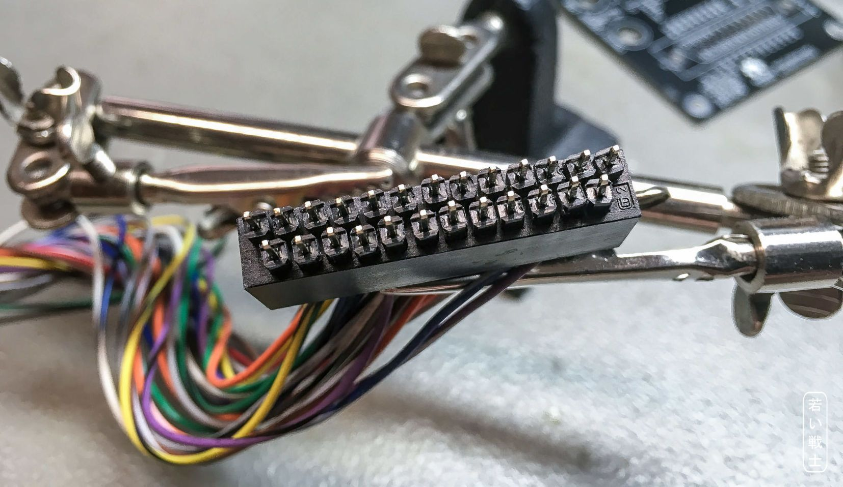

Figure 2: Alignment of the pins in a C128 keyboard connector

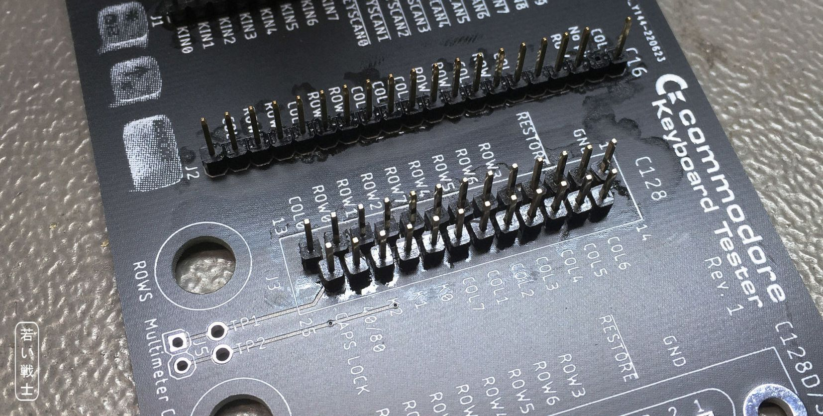

Figure 3: Soldered in C128 keyboard header (25 single pin headers) PCB Rev. 1

## The C128D/SX-64 connector (J4)

This is a 25p DSub (female) connector. No further comments required.

## 2mm/4mm Lab Jack for the Multimeter

The lab jacks for the multimeter have to be connected the solder pads beside the Lab jack footptint with a short piece of wire. Some sorts are pretty hard to solder and tend to deform/melt. It is a good idea to remove as many parts as possible before soldering.

Non-insulated lab jacks can be just screwed in. The big solder pad is connected to the circuitry, so there is no extra cable required.

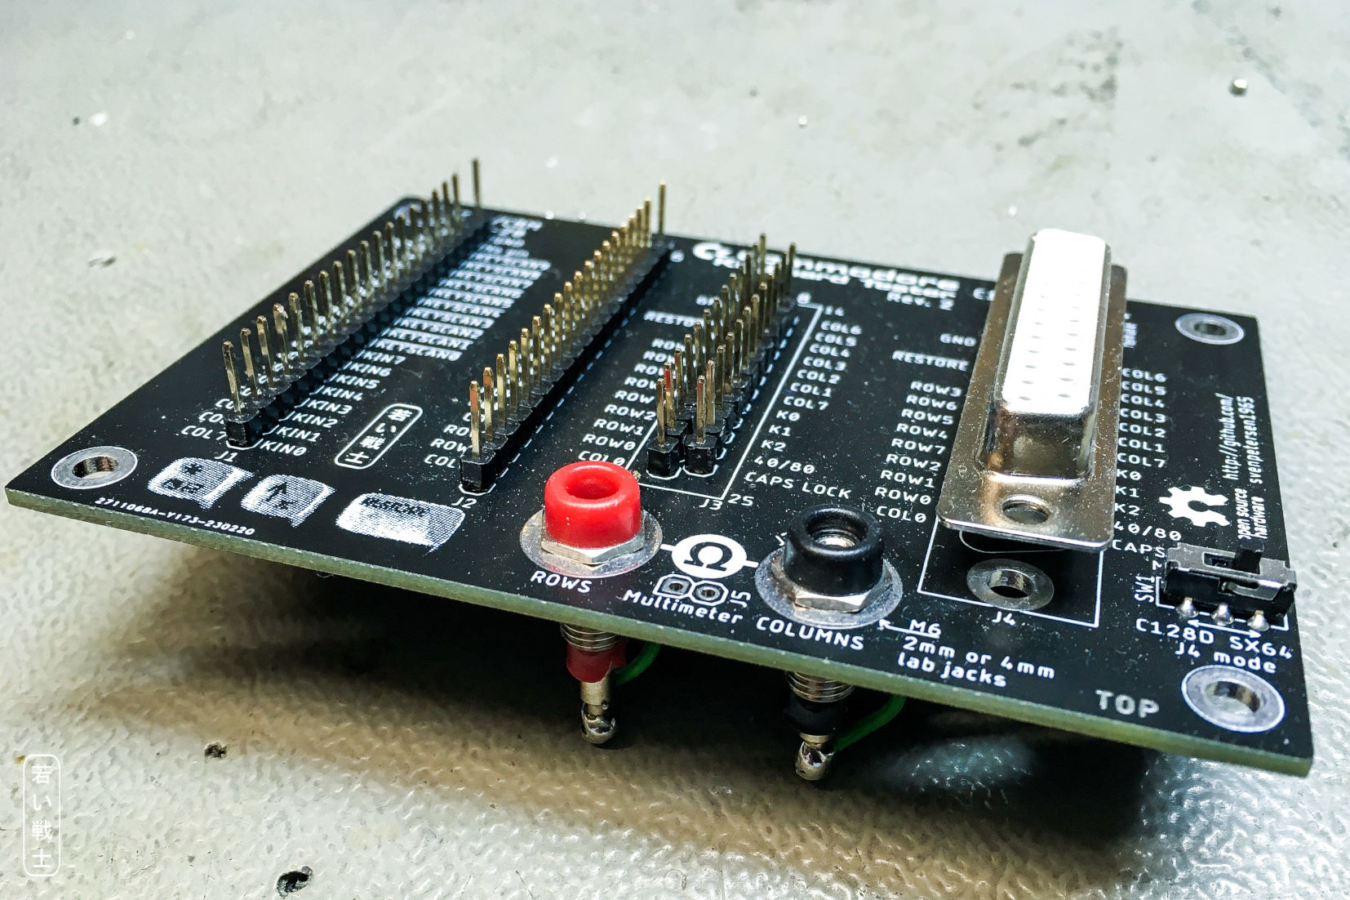

Figure 4: 2mm jacks for the multimeter

The lab jacks should be installed with all plastic parts on the component side of the PCB to keep the profile below the PCB as low as possible. 2mm and 4mm lab jacks with an M6 thread are suitable.

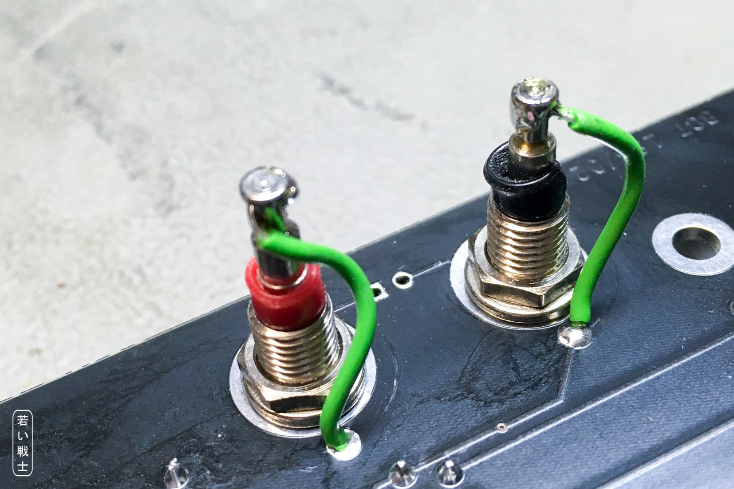

Figure 5: 2mm lab jack connected with a piece of wire

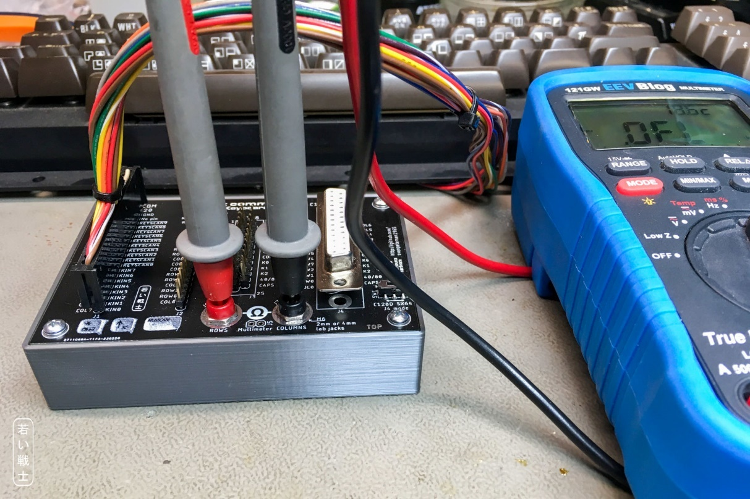

Figure 6: Keyboard Tester with 2mm jacks "in situ"

2mm lab jacks directly connect to the leads of a multimeter.

## Multimeter Pin Header (J5)

J5 is a standard pin header, which can be either vertical or a 90°-type. It is optional. I am using it with a one pin Dupont connector on a cable with a 4mm plug and that is pretty handy, too. However, J5 is in parallel with the lab jacks and it is **optional.**

## The C128D/SX-64 selection switch

The mini slide switch has a 2.54mm pitch in each row of pins. The distance of the rows is off pitch, though. This way, it also fits two 3pin 2.54mm jumpers.

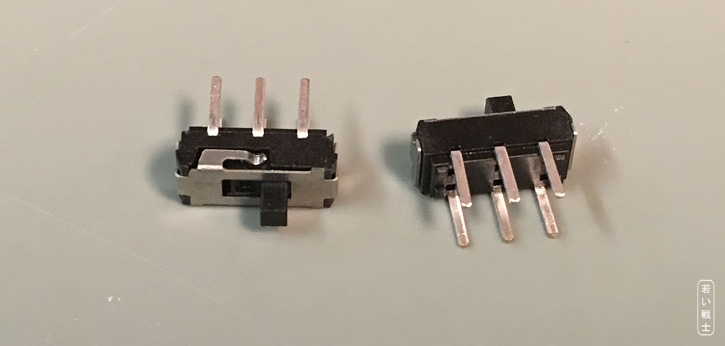

Figure 7: Mini slide switch

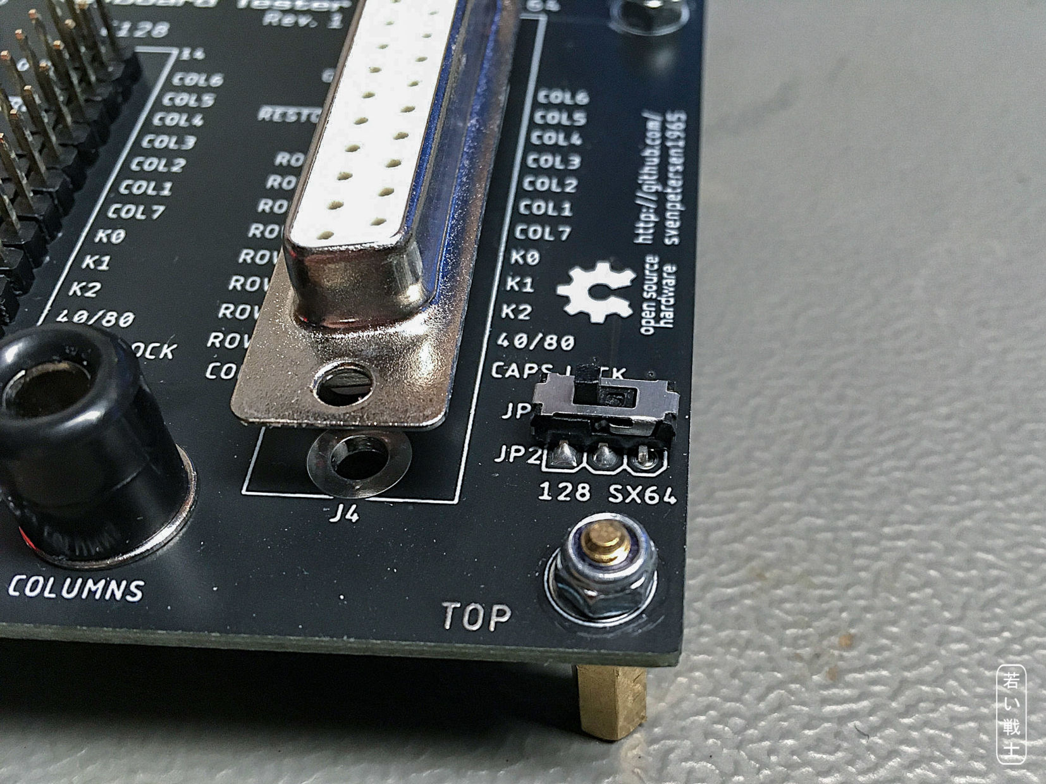

Figure 8: Slide switch placed instead of JP1 and JP2

These mini slide switches can be found on Amazon, Ebay and AliExpress. A possible search term is “mini slide switch dpdt” or “MSS22D18”, which will not show these switches exclusively, but it should not be too hard to find the right ones.

## The SX-64 Keyboard Cable

The original SX-64 keyboard cable does not fit with the female DSub on the Keyboard Tester, but a male

## The 3D-printed case

For the **2mm lab jacks**, the case needs to be 3mm deeper than for Rev. 0 and 1. If 4mm lab jacks are used, the Rev.0 case is still suitable (which saves a little bit of printing time.

Recommended screws: 4 each of 2.9mm x 6.5mm (self-taping) screws for sheet metal (C 2,9x6,5H, DIN 7981)

# The Use of the Keyboard Tester

A multimeter is required for using this keyboard tester. A good impedance is between 0Ω and a few 100 Ω. Probably, a keyboard works with even up to 3kΩ, but I would consider it as critical. Also, the different computers use different interface chips (VIA, CIA etc.) and even scanning is a bit different, so the limit for “good” might be different. In my opinion, everything above 600Ω requires inspection. 2kΩ might still work.

The keyboard is connected to the proper pin header, the multimeter is set to continuity test (“beeper”) mode or a low Ohms range. Every single key of the keyboard is pressed, one at a time and the value is read from the multimeter**. If a key does not produce a reading in continuity test mode, switch to normal Ohms mode**. This is slower, but sometimes the range in continuity test mode is too low to show a reading. The 121GW will display up to 550Ω, while the VC160 displays up to 400Ω in the continuity tester mode.

With the 121GW, it is possible to set the range from *auto* to *kΩ*, which will speed up the measurement from about 5 seconds to “almost immediate”.

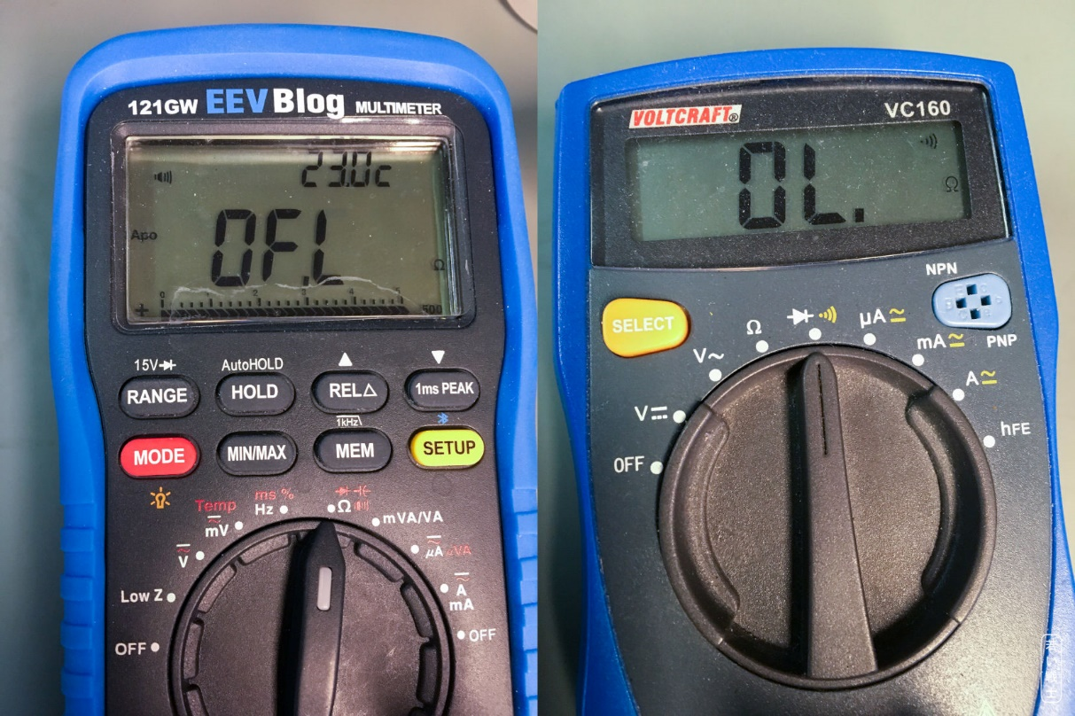

Figure 9: Multimeters in continuity test mode

***A key is high impedance, and now?***

There are different reasons for that, all require opening the keyboard and inspecting the thing.

Sometimes, dirt has collected under the failing key. That can be fixed easily. Carefully remove the dust/dirt. You can use isopropanol (rubbing alcohol, IPA) on the conductive rubbers and also on a golden surface PCB. Do not rub IPA hard on carbon contact key pads. The carbon contact could be damaged. It requires a more careful use of IPA or maybe even just demineralized water without a detergent.

Many keyboard PCBs use a “two layers on one side” technology with conductive bridges adhered to some contact points, that are crossing several copper traces. Those can get high impedance. I have fixed this kind of problems with soldering botch wires to the poorly contacted copper trace. Those botch wires should run on the bottom side of the PCB to not mechanically interfere with the keyboard. This might require drilling little holes for switching sides.

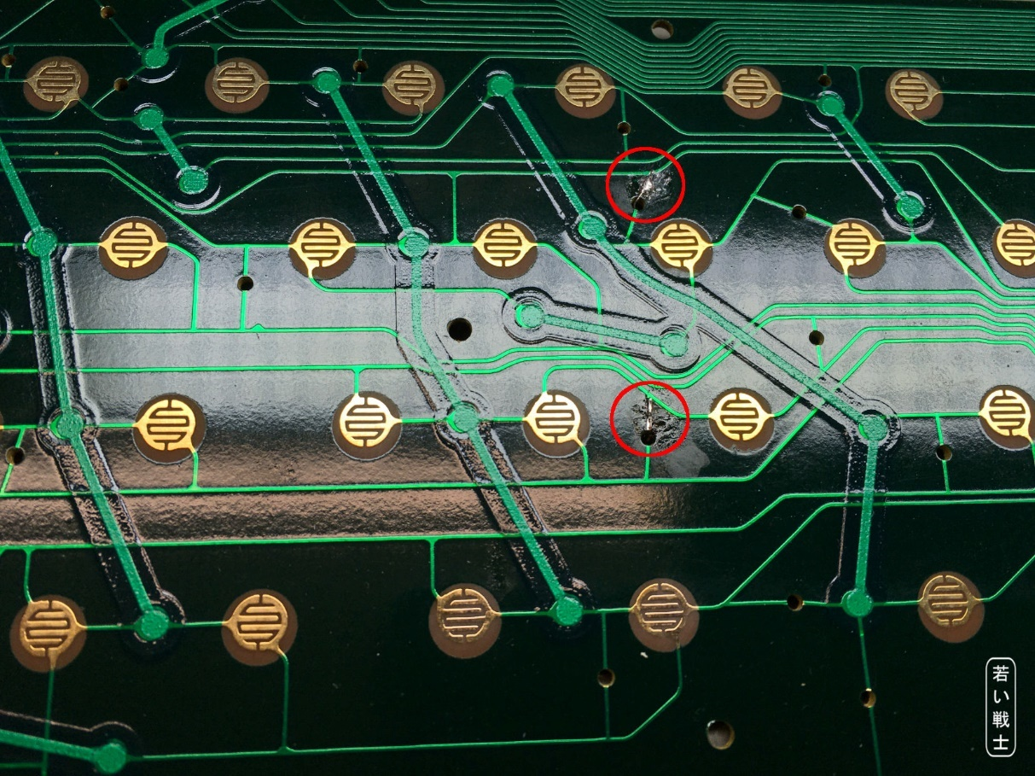

Figure 10: Botch wire repair (top side) solder joints

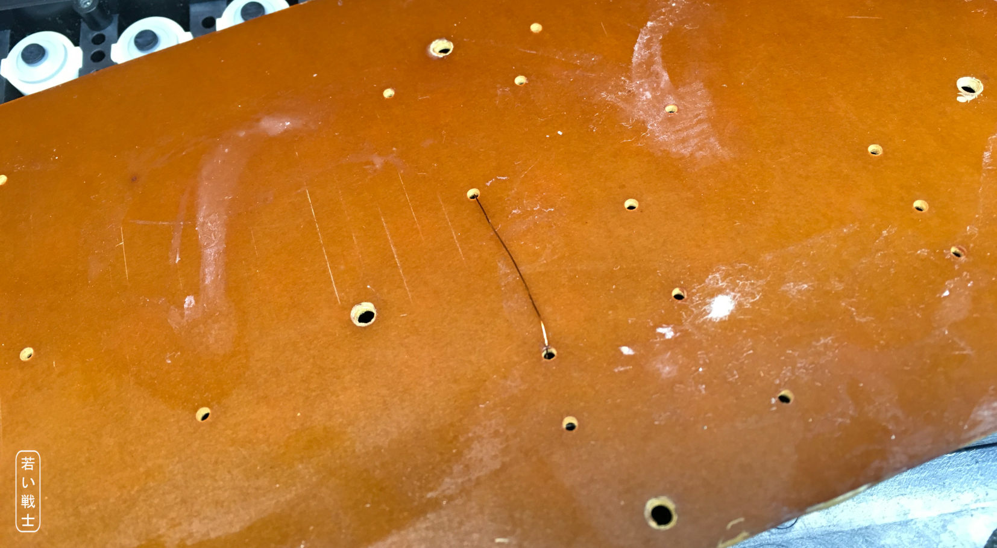

Figure 11: Botch wire repair (bottom side)

In this case, I have made use of the already existing drills in the PCB.

Jeff Birt from the “Hey Birt!” Youtube channel has done some research on aging conductive keyboard rubbers. He found out, that high impedance keyboard rubbers are caused by oils, that are escaping the rubber. He said, that removing theses oils requires a mild caustic solution.

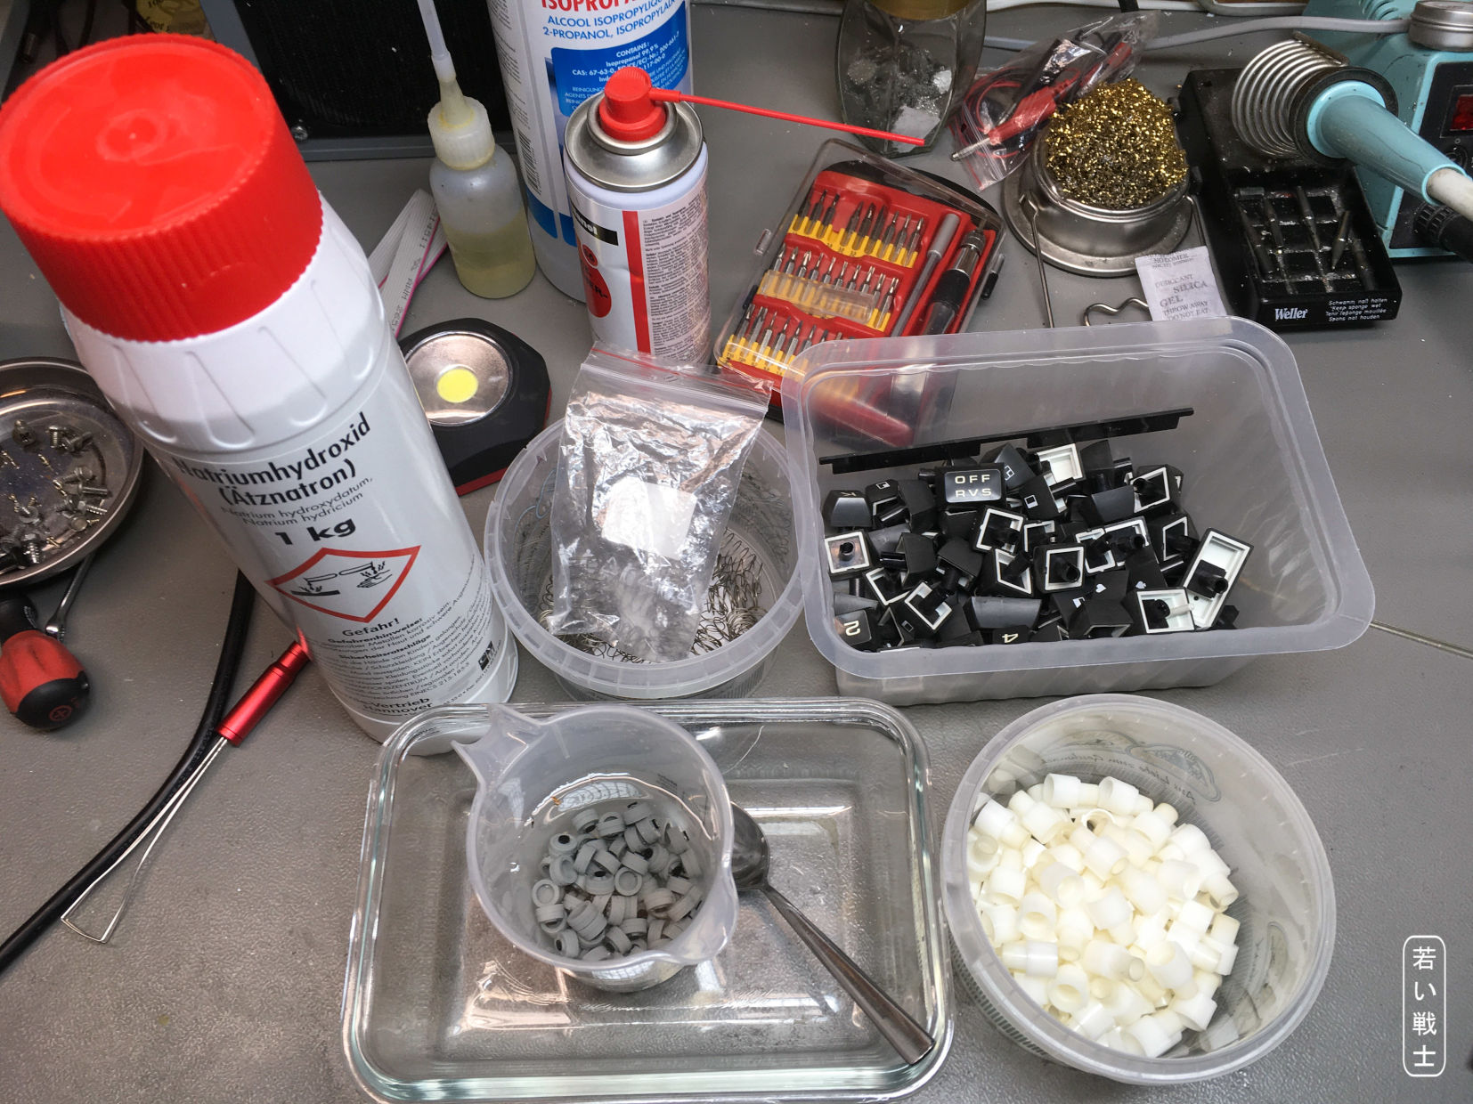

Figure 12: Rejuvenation the keyboard rubbers with a NaOH (lye) solution

I am using a lye (NaOH/sodium hydroxide) solution (1 teaspoon in 125ml of demineralized water). The keyboard rubbers need to be submerged in it for about 24 hours. After this treatment, they should be rinsed carefully (use a big enough sieve to not lose any) in tap water and finally in demineralized water. Finally, let it them dry on a kitchen paper over night.

This is quite a bit of work, but well worth it. Once, I had tried to get the rubbers out without disassembling the keyboard on a C16 keyboard and accidentally destroyed one. Also, it might be good to clean every single part of a keyboard on a newly acquired computer, anyway.

# Revision History

## Rev. 0

* The prototype worked with all, except the SX-64 Keyboard.

## Rev. 0 → Rev. 1

* Jumper/Switch added for configuring the C128D or the SX-64 keyboard
* Fully functional

## Rev. 1 → Rev. 2

* Improvement of the silk screen print
* The functionality is identical to Rev. 1